CURRICULUM VITAE
Objective:  To become associated with a company where I can utilize my skills and gain further experience while enhancing the company’s output and standing.  P. Kandharam |  |  | 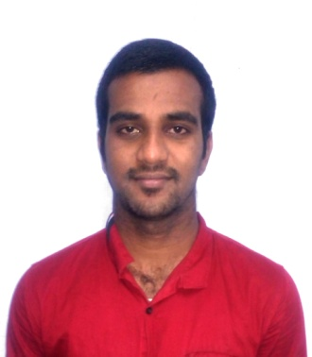
- Name |  | P. KANDHARAM
- Father’s name | : | S. PERUMAL
- Permanent address | : | 9/118, Sattur main road,  CSI Church complex,  Elayirampannai, Sattur (Taluk),  Virudhunagar (Dist), Pin- 626 201
- Email | : | kandharam25@gmail.com
- Contact number | : | 9585960558
- Date of Birth (DOB) | : | 04.06.1993
- Languages Known | : | Tamil, English & Telugu
- Hobbies | : | Reading books, Cricket, Volley ball, Badminton, Fishing

9. Academic qualification
Educational  Qualification | Institution | Year of passing | Class | % of marks
BFSc | Fisheries College and Research Institute , Thoothukudi-08 | 2014 | SECOND | 72.7
HSC | Nadar Mahamai Higher Secondary School, Elayirampannai-626201 | 2010 | FIRST | 81.83
SSLC | Nadar Mahamai Higher Secondary school, Elayirampannai-626201. | 2008 | FIRST | 94.2

15. Work Experience:

2016 - Area Sales Officer, Neospark Drugs and Chemicals Private limited,
Hyderabad, India. (2016 – Present)

Assigned Territory: Pattukottai, Tamil Nadu

I have more than three years’ experience in sales and marketing of shrimp health care products and in shrimp farming as well.
The prime objective of my position in the company is to ensure development of assigned territory through achieving sales and collection target through expanding the customer and product base by providing all required services to the customers.

2019 - I have more than one year experience in techncal and sales of fish feed and hatchery seed production

Assigned territory- overall Tamilnadu
16. Workshop:
- ‘Application of Remote Sensing and GIS in Fisheries and Coastal Zone Management’ in Integrated Coastal and Marine Area Management (ICMAM) Project Directorate, Chennai.
17. Training:
- Completed ‘Rural Awareness Work Experience (RAWE)’ program for 110 days in Shrimp farm, fresh water & marine water fish farm, ornamental fish farm and shrimp processing plant.
- ‘Technological Production of Ornamental Fishes and Live Food Organisms’ at Fisheries Research and Extension Center, Tamil Nadu Fisheries University, Chennai.
18. Technical standing:
- Shrimp farming (Pacific Whiteleg Shrimp)
- Inland fish farming (Indian Major Carps)
- Ornamental fish culture (Live bearers and Egg layers)
- Water quality parameter analysis
- Basic microbiology
- Waste water management
- Fisheries resource management
- Preparation of value added fishery products
- Basic knowledge in computer operating (MS Office)

s19. Social work:
Undergone seven days “special NSS camp” Kootampuli village, Tuticorin.

DECLARAION:
I hereby declare that all details furnished above are true to the best of my knowledge and belief. I will be sincere in my work and loyal to the organization.

Yours faithfully
